

SCC306 Internet Applications Engineering

Coursework Element 2: Responsive & Accessible Web Design

**Matthew Bradbury and Phillip Benachour**

Please note that this workbook should be anonymous. Do not include your name in the workbook.

# Introduction

In this workbook, we will be looking at both responsive and accessible web design. In Part 1, we will focus on how to build an accessible website, whilst Part 2 looks at how to approach responsive web design.

For both parts of the exercise we will use the same template website and build upon it throughout. In other words, once you have completed Part 1, the same website will be used for Part 2 – no need to start again.

The template website is provided on Moodle. The template consists of these files: index.html, style.css, icon.png, aerial.png, banner.png.

Once you are finished with both parts of this workbook, please submit all of your code and this workbook (as a single zipped folder) using the submission point provided in Moodle.

# Part 1: Accessible Web Design

The first part of this workbook is to examine accessibility for the supplied website. This involves identifying the issues that are causing the web page to be poorly accessible to some audiences, and then fixing a subset of these by modifying the web page.

To begin with, we recommend you review the BBC’s Standards and Guidelines for Mobile Accessibility: [http://www.bbc.co.uk/accessibility/forproducts/](https://eur02.safelinks.protection.outlook.com/?url=http%3A%2F%2Fwww.bbc.co.uk%2Faccessibility%2Fforproducts%2F&data=02|01|m.broadbent@lancaster.ac.uk|e7ea4d596f784ab0e8e008d75b9cf6cf|9c9bcd11977a4e9ca9a0bc734090164a|1|0|637078602042853481&sdata=tdD%2B6TOCzJmg47jCNWX%2Bi79bEmloJPOjJa6TY3C0QMs%3D&reserved=0)

You may also find the following resources useful:

<https://tenon.io/>

<http://wave.webaim.org/>

https://www.w3.org/WAI/standards-guidelines/

Throughout this section you should refer to appropriate accessibility standards or guidelines by citing them. You may choose which citation style you use, but should be consistent throughout the workbook.

# Accessibility Issues

For the first task, and using the resources given above, review the existing website and assess to what extent it meets the criteria, particularly those described in the BBC’s guidelines.

Create a list of issues, being clear at each stage what the issue is, and referring to the guidelines to be clear which specific accessibility feature is being violated. You should explain how the issue violates the guidelines/standards/recommendations you reference. To accompany this text, provide evidence of each using a screenshot, you may include a screenshot of the DOM if necessary.

|  |  |
| --- | --- |
| **List of Issues** |  |
| * The first accessibility issue I could immediately identify in the website would be the contrast between the blue and black in the tab fields (or menu) of the website. It directly violates the 1.4 Distinguishable standards for 1.4.3 Contrast (Minimum) in the WCAG 2.1 guidelines, which states that the visual presentation of text and images of text has a contrast ratio of at least 4.5:1, except for a few special scenarios, as in our case, the contrast between the colours is 1.47:1, as per stated in <https://webaim.org/resources/contrastchecker/> . In the checker, this combination of colours fails every test, as it would significantly create struggles for users with low vision or colour deficiencies to access content without using additional assistive technologies. Users who are blind, have low vision, or especially colour deficiencies are not going to be able to differentiate the content in this menu bar:      * The second thing I notice is that there are no image alternatives to the images on the website. If for an instance, images fail to load or users have a vision impairment, they won’t be able to process what the image is, so we need an alt attribute to associate alternative text content with an image in any HTML document. This violates two main guidelines, one would be in the 1.2 Time-based Media standards for 1.2.3 Media alternatives and 2.5 Input Modalities standards for 2.5.3 Label in Name, as both state that if a person has a vision impairment, and is not able to see the images, there should be an alternative tag line to help the screen reader recognise the image and put a label on it, presenting what it is. * Another problem that the website encounters is that it is not indicating a language, which is definitely a must, as for people who are listening or using assistive technologies like screen readers would need to know what’s the language of the website so the speech synthesizer is adjusted. A word in English can mean something totally different in another language. This is directly violating the BBC Accessibility for Products section for Mobile Accessibility Guidelines – Editorial (Indicating Language). Looking at the code, we see that it is fully missing there. * The 4th problem the website has is that the main page has not been identified as unique and hasn’t been clearly identified. It is directly violating the BBC mobile accessibility guidelines – Structure (Unique page/screen titles). As the page title is usually the first thing people see on their monitors, it acts as a confirmation of where they have arrived at, generally helping people orientate where are they and if they are accessing the right resources. Accessibility wise it helps vision impaired users who cannot view or distinguish the whole page at once. It is used for identification, so it is pretty sufficient to be included in the design of a website. This happens by including a <title> tag in the head of the html document. In our website it is clearly missing, so we view the title like that:      * The 5th problem concerns spacing and more specifically disturbs the BBC mobile accessibility guidelines for Design (Spacing). It states that there should be an inactive space around all actionable elements in a website. This is for anyone that finds it challenging to interact with small and tiny controls, especially ones that are tightly grouped together. If a person with motor or vision impairment happens to be in such a situation, it would be nearly impossible for them to continue and do it appropriately. In our most actionable element, we do not have any spacing between the different buttons:     , which makes it less accessible for people with the disabilities said above. The minimum space possibly set would be 1 pixel, however, the more there is the better in many instances, as the space shall be larger.   * The 6th issue directly infers the BBC mobile accessibility guidelines for Structure(Headings), which states that there should be a logical and hierarchical heading structure, which is consistent around the whole website. It enables people to understand the content of the page quicklier, as well as, allows screen reader users to navigate easily within the screen. In our website, this consistent layout is disrupted in places, more specifically can be seen in here:     The headings here are different in style, which makes it way harder to people to follow the outline and navugate within the page.   * The 7th issue I’ve found is concerning and directly impacting the BBC Mobile Accessibility Guidelines for Design (Visible focus), which states that all actionably and focusable elements must have a visible state change. In our case, for instance in the tab bar menu, whenever we hover over an element, nothing changes, so there really isn’t a way to easily recognise if the element is clickable or actionable straightaway. This is an issue for sighted keyboard and switch device users that track progress as they navigate throughout a webpage, as well as, people controlling with a TV interface or generally touch users, as they would receive a confirmation that an element is interactive. The issue could be easily seen here:     A hovering change of state should be introduced so people can navigate easily.   * The 8th problem I’ve encountered is concerning the BBC Mobile Accessibility Guidelines – Design (Content resizing), which states that users must be able to control themselves the font sizing and user interface scaling, meaning that when it doesn’t happen or exist in a website, users with vision impairment, or generally users who like to zoom in to view clearer are in a disadvantage and unable to adapt towards the size of the content to see. This happens when someone tries to zoom in on the website, it surely can be done in a better way: | |

# Accessibility Fixes

From the list you have identified above, choose 4unique issues, each of which require a different *type* of fix. In the following section, work through each of these issues, first by identifying the offending code/content, using a snippet to highlight exactly where the issue has occurred.

Then, using the knowledge you have gained from the Accessibility lecture and associated readings, provide the fix to address each accessibility problem. To do this, document the fix using code/content snippets, and provide *evidence* of how it resolves the accessibility problem in the rendered web page. Use a small textual description to aid your explanation of *how* you achieved the fix. Refer to appropriate guidelines/standards/recommendations as to how your change has now resolved the accessibility problem.

# Accessibility Fix 1

|  |  |
| --- | --- |
| **Explanation, code extracts, screenshots/ evidence** |  |
| Here, we are going to fix the first issue we identify in our list, which is the contrast between the blue and black in the tab field at the top of our page. The code that causes this problem is the following in our .css file, where it customises the ul{} and li a{} elements:    The lines that identify the colours would be the background-color: #333 in the ul element and the color: blue in the li a element. In order to fix this, we need to change the colour and achieve a ratio higher than 4.5:1 as per the guidelines state. The fix is the following:    This changes the colour of the text in the menu element, making the it white, which achieves a contrast ratio of 12.63:1, meeting the guidelines of a 4.5:1 minimum:  <https://webaim.org/resources/contrastchecker/>    We’ve resolved the issue and now meet the guideline for minimum contrast of text, being more accessible to people with vision disabilities. Our solution even passes the 1.4.6 Contrast (Enhanced) guidelines, as our contrast ratio is higher than the one specified there being at least 7:1, which means we now have an optimal accessibility with the text. | |

# Accessibility Fix 2

|  |  |
| --- | --- |
| **Explanation, code extracts, screenshots/ evidence** |  |
| Here we are going to fix the second issues in our list, which is the missing alternative tag line for images, which prevents screen readers, subtitles and etc to recognise images, so by putting one on the image section in our code, we are going to help people with vision impairments associate alternative text content with an image. The issue is the missing alt attribute:    What I am going to do to fix it, is add this alt attribute and put a meaningful associative text for the respective images: | |

# Accessibility Fix 3

|  |  |
| --- | --- |
| **Explanation, code extracts, screenshots/ evidence** |  |
| In this section, we’re going to the look at the missing indicating language component. The missing part is located in the the very first lines where the <html> tag is opened:    Now, in order to fix this issue, we have to add a language specification to the html tag. This is going to help people who are listening or using assistive technologies like screen readers who would need to know what’s the language of the website so the speech synthesizer they use is adjusted and doesn’t interpret words in a different way than the specified language. The fix is done like that:    Now, we have specified that the language of the website is British English. We’ve checked it works and per the BBC mobile accessiblity guidelines for Editorial(indicating language) have been met now. | |

# Accessibility Fix 4

|  |  |
| --- | --- |
| **Explanation, code extracts, screenshots/ evidence** |  |
| In this section, we’re going to be looking at the page title issue and specifically how the lack of it undermines people orientating themselves within websites and apps. Within the BBC mobile accessibility guidelines – Structure(unique page/screen titles), we need to introduce a title for our unique page, so that vision impaired user who cannot perceive the whole page at once can still identify what resources are they looking at and orientate around the web. The troubled section in our code is the following, within the head of the html file:    We need to add a title tag in there, specifying the name of the page. We’re going to do that in the following way:    The title tag is fixing our issues, making it look like that:    Now people can immediately know what unique page are they on and orientate themselves. | |

# Part 2: Responsive Web Design

In this part of the workbook we will be focusing on building a responsive website, using the same code/content you have worked on and improved in the previous part of this exercise.

To begin with, you will familiarise yourselves with the techniques, tools and approaches necessary to build a responsive website. You will then move on to applying these concepts to make the existing website responsive.

# Getting Started

These initial exercises will help you to get started with this element of the coursework.

## Exercise 1: Chrome developer tools device mode

In this exercise, you will use the Chrome developer tools with device mode enabled. Device mode allows you to spoof the User Agent (UA) and emulate screen sizes of different mobile devices. This tool is particularly useful for checking if your website will be viewable on a range of devices and can also be used to identify the breakpoints of existing responsive websites.

To use device mode in Google Chrome, go to developer tools and select device mode:

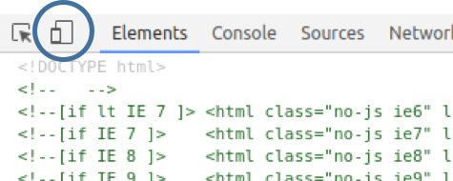

Click on the settings button on the top right-hand corner of the page and enable “Show media queries”:

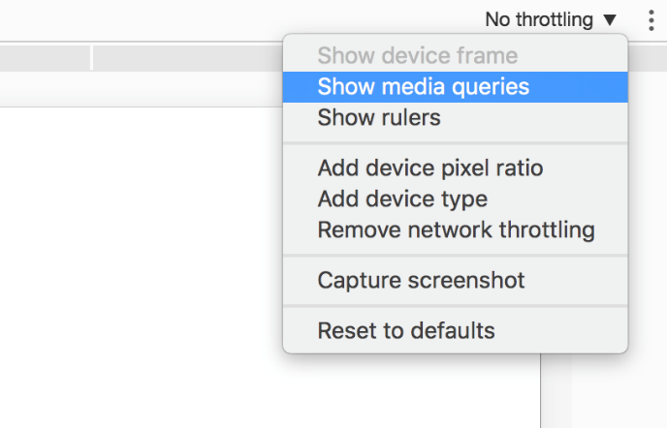

At the top of your browser, there will be the breakpoints for the webpage. Go to <http://www.lancaster.ac.uk/> and see what breakpoints they have designed, e.g.:

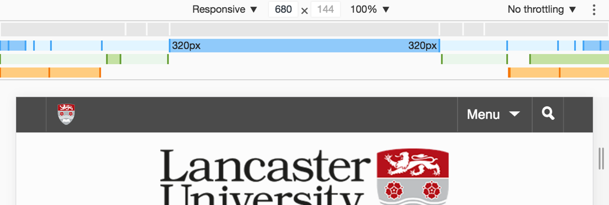

More information about device mode is available at:

<https://developers.google.com/web/tools/chrome-devtools/device-mode/>

Next, examine how these websites change when you select devices of different resolutions. Identify the breakpoints of each site (resize the page until a change is triggered):

• [http://www.youtube.com](http://www.youtube.com/)

• [https://modules.lancaster.ac.uk](https://modules.lancaster.ac.uk/)

## Exercise 2: W3schools responsive web design

We **strongly** recommend that you go through the *entire* responsive section available at W3Schools to familiarise yourself with the fundamentals.

<http://www.w3schools.com/css/css_rwd_intro.asp>

# Responsive Web Design Assignment

For this exercise, you will make changes to the web page you have already been working on to enable a responsive design. This should react to different screen sizes and widths. To do this, you need to provide screenshots of your website at each breakpoint as instructed. Use the Chrome developer tools in device mode to capture the **entire page** (take multiple screenshots or scale the page if required). You must also provide an explanation of the methods used to make the website look the way it is at **each breakpoint**. To support this, include extracts of your code accordingly.

For any additional features you may have added, show and explain code and screenshots. Finally, explain how the feature improves the responsiveness of the website.

Once you have completed both parts of this workbook, upload your website and workbook to Moodle (include index.html, style.css, icon.png, aerial.png, banner.png, this lab book document, and any other files you may have used).

In this new website, we expect to see the following principles:

* Media Queries
* Fluid Grids
* Fluid Images

You may also consider using features that facilitate intrinsic web design, such as with intrinsic grids and the intrinsic sidebar. The coursework should target the feature set of Chrome 107.

The responsive website you create should cater for a range of devices:

* Mobiles (425px)
* Tablets (768px)
* Laptops (1024px)
* Large Laptops/Desktops (1440px)

**Additional marks** will be available to students who provide and *justify* up to two other responsive features appropriately. Examples include but are not limited to:

* Using a touch friendly ‘burger’ or vertical menu on a break in design.
* Creating a collapsible box, only showing the most important content until expanded.

The following are mock-ups of what we expect the website to look like at each breakpoint. Whilst you are free to experiment with the design, when making your website try to replicate the **structure** shown in the mock-ups as much as possible. To evidence your responsive website, download the workbook from Moodle and fill in each section.

Note: You may use any framework, tools, or techniques that you wish to complete this task. However, this assignment can be accomplished with the use of CSS alone, as shown in Exercise 2.

## Large Laptop/Desktop (1440px)

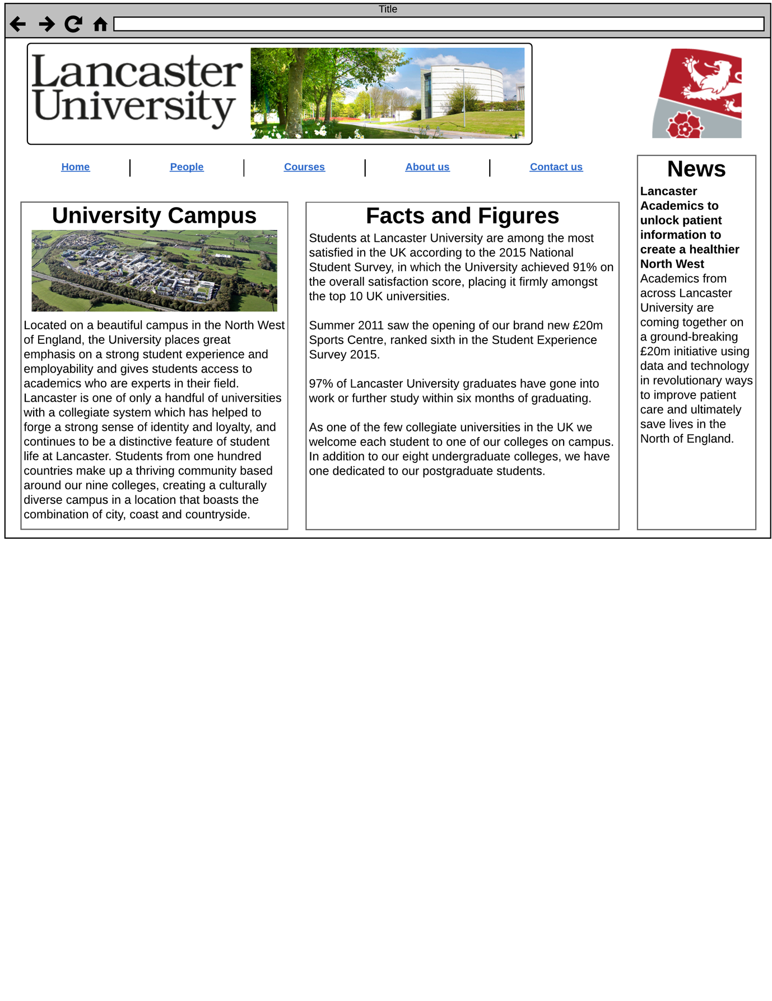

## Laptop (1024px)

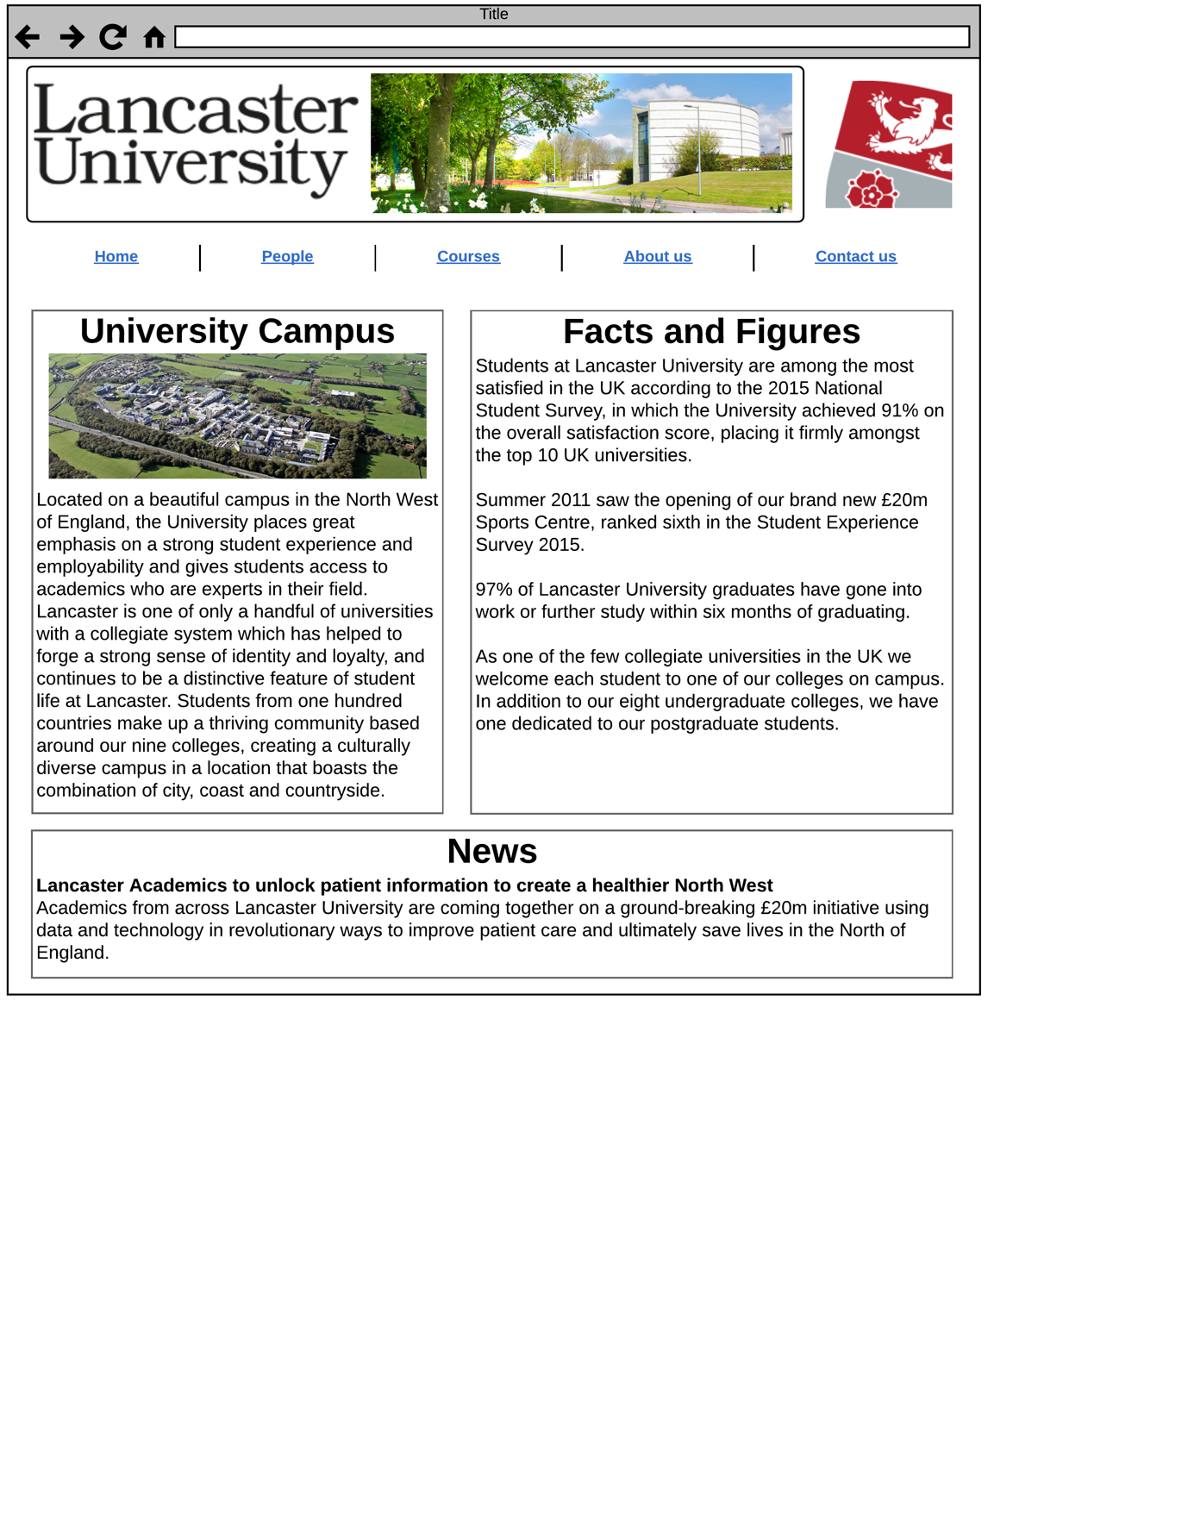

## Tablet (768px)

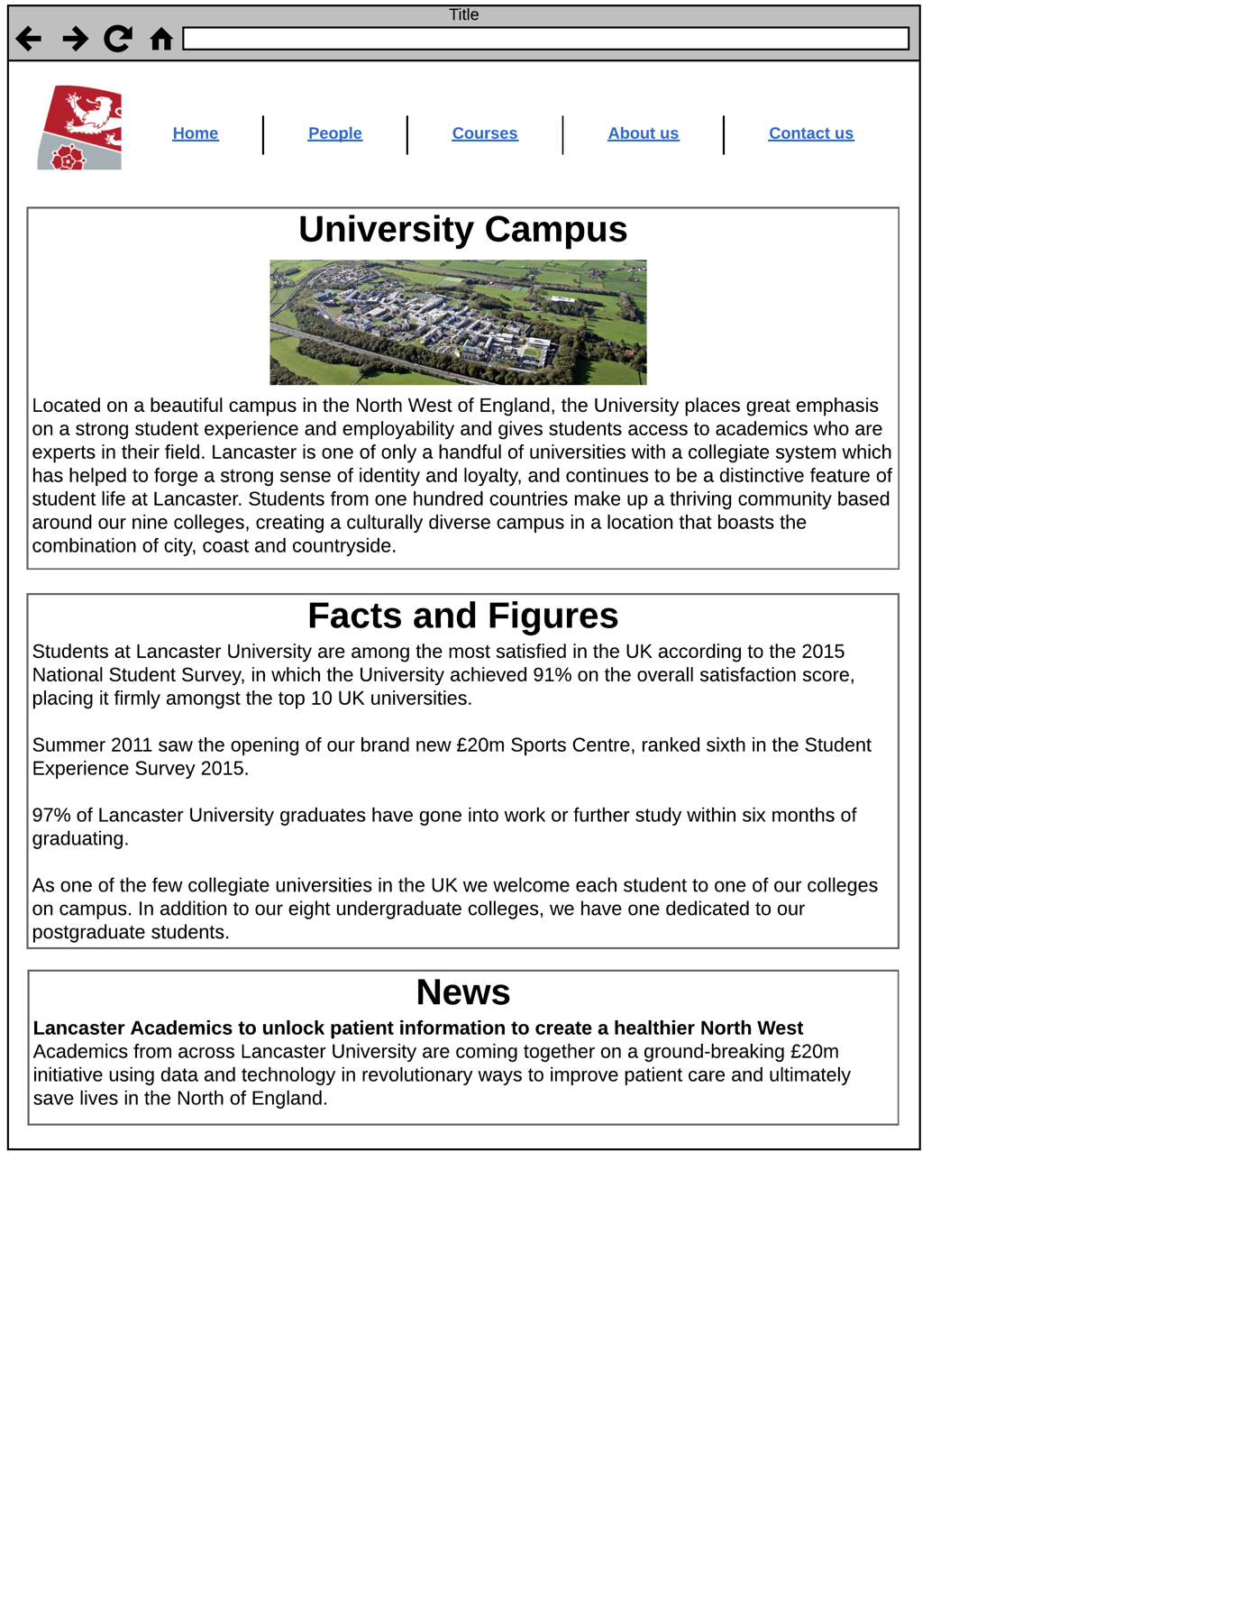

## Mobile (425px)

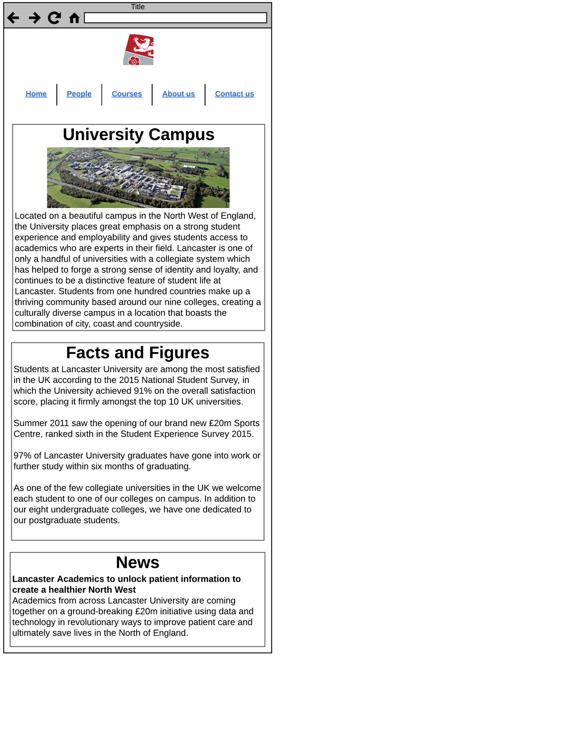

# Laptop Large/Desktop (1440px)

|  |  |
| --- | --- |
| **Screenshot at 1440px (website and breakpoint using device mode)** |  |
|  | |

|  |  |
| --- | --- |
| **Code extracts and explanation** |  |
| The way I’ve done the main part of this media query breakpoint is by doing the following code:    the @media only screen line defines that the following layout is only going to be for the desktop media query with minimum width of the screen being 1440 pixels. Afterwards I’ve created a container and specified that the container is going to be a grid, while also specifying the number of columns and rows in the template and their sizes. In this section I’ve gone for 4 columns in grid-template-columns, each taking a different propotion of the screen and 3 rows, all of them being the same size. In the line grid-template-areas I’ve defined the position of all of the elements and the places of the grid they are going to take, creating the main layout.    Afterwards I’ve defined each of the elements in the .css file by their html tag id name and called them so that I can modify them following the template. For each of the main elements, there’s a border around, just like we see in the #header, and almost every element has a form of padding around so that it can be adjusted and effective towards responsiveness and accessibility. The main model of formatting elements can also be seen in this snippet of code:    Firstly, I’m looking at the main id of the element, creating a border around it, giving it a bit of space to breathe with the padding, and then it is followed by other methods, each specifying a different component of the whole element, h1 is going to be the header, img is going to be the image in it, while p would be the normal text. I’ve modified each in design, so that it follows the template as well, which is achieved by aligning both texts and images, and playing with the format of the normal text. | |

# Laptop (1024px)

|  |  |
| --- | --- |
| **Screenshot at 1024px (website and breakpoint using device mode)** |  |
|  | |

|  |  |
| --- | --- |
| **Code extracts and explanation** |  |
|  | |

# Tablet (768px)

|  |  |
| --- | --- |
| **Screenshot at 768px (website and breakpoint using device mode)** |  |
|  | |

|  |  |
| --- | --- |
| **Code extracts and explanation** |  |
|  | |

# Mobile (425px)

|  |  |
| --- | --- |
| **Screenshot at 425px (website and breakpoint using device mode)** |  |
|  | |

|  |  |
| --- | --- |
| **Code extracts and explanation** |  |
|  | |

# Additional Feature 1

|  |  |
| --- | --- |
| **Screenshot at relevant breakpoint** |  |
|  | |

|  |  |
| --- | --- |
| **Code extracts and explanation** |  |
|  | |

# Additional Feature 2

|  |  |
| --- | --- |
| **Screenshot at relevant breakpoint** |  |
|  | |

|  |  |
| --- | --- |
| **Code extracts and explanation** |  |
|  | |